Today, I want to take you on a journey — not just through technology, but through time

Think for a moment about how humans have evolved. From the invention of fire to the creation of the wheel, from handwritten letters to instant messages across the globe — our ability to adapt and innovate has shaped the world we live in.

In the early days of IT, we started with physical servers — big, bulky machines running a single application. Then came virtualization, allowing us to run many virtual servers on one machine. After that, the cloud changed the game, giving us flexibility and scale like never before.

But as our applications grew more complex, we needed something smarter to manage everything automatically— something that could evolve with us.

That’s where Kubernetes comes in :

It doesn’t just run applications — it **intelligently manages, heals, scales, and automates** them.It helps us **deploy, scale, manage, and recover** applications in a smarter and more efficient way

In simple words, Kubernetes is an **open-source container orchestration platform**

Imagine this — let’s say you’re running a big restaurant kitchen. You’ve got multiple chefs, ingredients, dishes to prepare, and orders coming in. If everyone just does their own thing without coordination, the kitchen becomes chaotic.

Now, if you have a **head chef** who knows how to assign tasks, monitor progress, handle mistakes, and ensure everything goes smoothly — the whole kitchen becomes efficient.

That’s exactly what Kubernetes does, but for your **containerized applications**.

Kubernetes was originally developed by Google — because they were already running billions of containers every week, and they needed an efficient way to manage all of that. Later, it was donated to the **Cloud Native Computing Foundation.**

**It provides:**

✅ Reliable Infrastructure – Keeps your applications running even if some parts fail.  
✅ Zero Downtime – Updates can happen without stopping the application.  
✅ Rollback Support – If something goes wrong, you can quickly revert to the previous version.  
✅ Auto Scaling – Automatically adds or removes resources based on demand.  
✅ Self-Healing – If a part of the application crashes, Kubernetes automatically replaces it to keep things running.

**Many cloud providers were afraid about evolution of Kubernetes. They thought their market value will drop as it can manage and deploy on premises system**

They found the little drawback of K8s, cluster creation and management have little disadvantage.

So, cloud provider has brought managed solution for kubernetes. leading cloud providers such as AWS, Azure introduces it to manage the control plane, and we manage the worker plane.

They manage the cluster creation in initially stages is bit complex. They take care of complete Master component – hosted cloud provider.

* Worker nodes are managed by us.
* Cloud Providers offer – high availability and fault tolerance.
* Worker nodes support 5000 node per cluster.
* Worker nodes are nothing but virtual machine or cloud instances. All these nodes are joined together to form a cluster to availability and replication purpose.

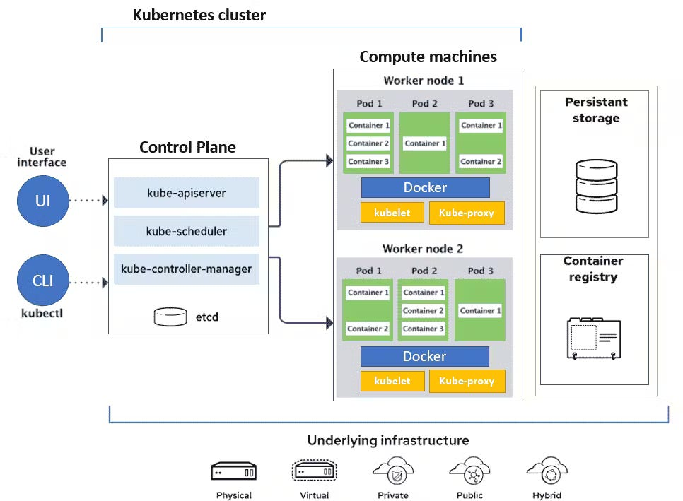

Core Components:

* **Cluster**: A group of nodes working together.
* **Node**: A single machine (physical or virtual) in the cluster, running containers.
* **Pod**: The smallest deployable unit in Kubernetes, usually containing one or more containers.

**Master or control plane** is responsible for scheduling, provisioning controlling and exposing an API to outside the world.

The Control Plane coordinates all activities in your cluster, such as scheduling applications, maintaining applications in desired state, scaling applications, and rolling out new updates.

* Assigning work to **Worker Nodes**
* Restarting containers if they fail
* Scaling applications up or down based on demand

**1. Brain = Control Plane**

* The **brain** decides **what to do**, **when**, and **how**.
* It receives instructions from outside (kubectl or CI/CD) and tells the body how to react.

**Kubernetes Control Plane = Brain**

* Understands your instructions (like running 3 apps).
* Plans where to run things.
* Makes decisions like: “A hand isn’t working, let’s move the task to the leg.”

**Four components**

**1. API Server** is kind of gateway for entire cluster if anyone wants to talks to Kubernetes, if you want to create, update, delete and display any Kubernetes objects, it has to go through API Server.

How do you interact with API Server?

Using Kubectl (kube control) is a tiny go-language binary communicates to API server to perform any operations from command line.

**2.Scheduler**

**You may probably have 5 nodes, how does Kubernetes decide where to run which container.**

**The Scheduler** is responsible for the scheduling of containers across the nodes in the cluster.

* Scheduling decisions are based on:
  + Resource availability
  + Taints/tolerations
  + Node/pod affinity rules
  + Custom policies

**3.Etcd** is a crucial component for Kubernetes as it stores the entire state of the cluster: its configuration, specifications, and the statuses of the running workloads.

Application metadata(number of pods, ports ,their current state, namespace).

This is **etcd**, the **central storage** of all your known actions and current state (like remembering how many Pods are running, and what Nodes are available).

**4.Controller**

**Think of Kubernetes Controllers as managers in a company. Just like managers ensure that work is done properly, controllers in Kubernetes make sure applications run as expected.**

**1️.What is a Kubernetes Controller?**

Imagine you own a restaurant. You want to make sure:  
✔ Enough chefs are cooking food  
✔ If a chef leaves, another one takes their place  
✔ Customers are served on time  
✔ Food is prepared as per orders

**In Kubernetes, controllers do the same for your applications. They ensure that:**✔ Enough application instances (pods) are running  
✔ If one fails, a new one starts automatically  
✔ Updates happen smoothly without downtime  
✔ The system adapts to traffic and workload changes

**🔹 cloud-controller-manager (optional)**

* Interfaces with cloud providers (GCP, Azure, AWS).
* Manages cloud resources: load balancers, IPs, storage, etc.



**Worker Nodes**

**Kubernetes Worker Nodes – The Backbone of Kubernetes**

In Kubernetes, Worker Nodes are the machines where applications actually run. They handle all the workloads, execute tasks, and ensure everything runs smoothly. Let's break it down in a simple way.

**📌 Think of Worker Nodes as factory workers in a large company:**

* **The Manager (Control Plane) gives orders.**
* **The Workers (Worker Nodes) actually do the work.**

**🛠️ Components of a Worker Node**

Each worker node has three key components that allow it to function in Kubernetes:

**1️.Kubelet (Supervisor of Containers)**

* Kubelet is like a supervisor on the worker node.
* It takes orders from the Control Plane and ensures that containers (applications) are running as expected.
* Kubelet will load the container image.
* If a container crashes, Kubelet helps restart it.
* Main agent on each node.
* Talks to the API server to get instructions.
* Ensures containers are running as specified in the PodSpec.
* Reports status of containers and node.

🔹 Example Use Case:

* If a web server container crashes, the Kubelet ensures it's restarted automatically.

**2. Kube-Proxy (Traffic Manager)**

* **This is like a traffic controller that manages network communication between different applications.**
* **It ensures that requests reach the correct container inside the node.**

**🔹 Example Use Case:**

* **If a user requests a webpage from an application running in Kubernetes, Kube-Proxy makes sure the request reaches the right container.**

**2️⃣ Container Runtime (Engine that Runs Containers)**

* **This is the software that actually runs the containers on a node.**
* **Kubernetes supports different container runtimes like Docker, containerd, and CRI-O.**

**When Kubernetes wants to start an application, the container runtime pulls the container image (e.g., from Docker Hub) and runs it inside the node.**

**🛠 Step-by-Step Interaction Between Kubernetes Components**

**Step 1: kubectl Sends a Request to the API Server**

* The kubectl apply -f my-app.yaml command sends a request to the API Server (kube-apiserver).
* The API Server validates the request and checks RBAC (Role-Based Access Control) to see if the user has permission to create resources.

🔧 Components Involved: kube-apiserver, RBAC

It **validates** the YAML:

* Is the syntax correct?
* Is this a supported API version?
* Does the user have permission to do this?

**Step 2: API Server Stores Deployment Data in etcd**

* The API Server stores the deployment request in etcd, which acts as the Kubernetes database.
* etcd maintains the desired state of the cluster.

Saves your deployment request to etcd, the key-value database of Kubernetes



**Step 4:**

🤖 Controller says:  
*"Hey! I see you want 3 replicas of this app. Let me make that happen."*

• Watches etcd for changes

• Compares actual state with the desired state

• Decides to create Pod objects accordingly

It creates **Pod objects** (with spec.nodeName = null) and sends them to the **API Server**

• 🔧 **Component Involved**: Deployment Controller (via kube-controller-manager)

**Step 3: Scheduler Decides Where to Run the Pod**

**🧠 Scheduler says:**

***"Hmm... Where should I run these pods? Let me find the best node."***

**Scheduler watches the API Server for pods without a node assignment:**

* The Kubernetes Scheduler picks a suitable worker node to run the pod.
* It considers factors like CPU, memory availability, affinity rules, etc.
* Once a worker node is selected, the scheduler updates the pod assignment in etcd.

• It finds the new unassigned pod

• Calculates where the pod should go (based on CPU, memory, taints, affinity, etc.)

• Writes the decision back to the API Server:  
→ spec.nodeName = "worker-node-1"

**Writes the decision back to etcd**

**Step 4: Kubelet on the Worker Node Creates the Pod**

**👷 Kubelet on Node says:  
*"Alright! I’ve got the job. Time to bring up this pod."***

* The Kubelet running on the assigned worker node detects that a new pod needs to be created.
* It communicates with the Container Runtime (Docker, containerd, or CRI-O) to pull the application image and start the container.

**Step 5: Container Runtime Runs the Application**

* **The Container Runtime (e.g., Docker) pulls the container image from a container registry (e.g., Docker Hub).**
* **It creates and starts the application container on the worker node.**

**Step 6: Kubelet Reports Pod Status to API Server**

**Hey API Server, I started the pod, it’s running fine**

* **The Kubelet continuously monitors the pod and reports its status (e.g., Running, Failed, Pending) to the API Server.**

**The API Server updates etcd with the pod’s latest status**

**Step 7: Exposing the Application Using a Service**

* **If a Kubernetes Service is defined, it assigns a Cluster IP or Load Balancer IP to the pod.**
* **The Service Controller ensures that traffic is routed correctly to the running pods.**

💥 What Happens When a Pod Crashes?

😵 Pod: *"Oops! I crashed!"*  
🤖 Controller: *"Don’t worry, I’ll replace you."*

* The **kubelet** detects the pod has failed.
* It updates the status to the API Server.
* The **Deployment Controller** sees that the actual number of running pods is less than desired.
* It **automatically creates a new pod** to replace the crashed one.
* Scheduler reassigns it, kubelet runs it again.

**🧠 1. User Interaction / YAML Apply**

* You kubectl apply -f pod.yaml
* This goes to the **API Server**

**🛡️ 2. API Server**

* The **only component** that talks **directly** to etcd
* It **stores** the desired state (e.g., the Pod spec) into etcd
* Acts as a **gatekeeper** and **REST front-end** for all Kubernetes state

**📌 3. Scheduler**

* Watches the API Server for **unassigned Pods**
* Decides the **best node** for a Pod
* It then **sends a PATCH request** back to the API Server to update the Pod object with .spec.nodeName
* ✅ So, **Scheduler talks only to the API Server**, not to etcd directly

**📌 4. Controller Manager**

* Watches the API Server for changes (like ReplicaSets needing Pods)
* When it detects something (e.g., not enough Pods running), it **sends updated object info to the API Server** (like new Pod specs)
* Again, **Controller never talks directly to etcd**

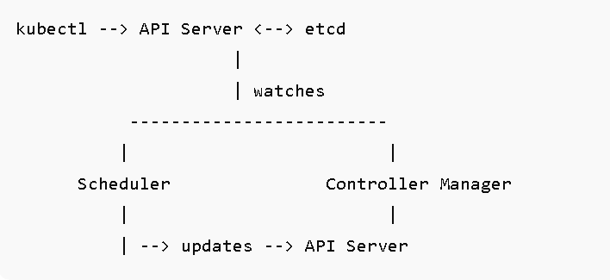

**🌩️ What is the Azure Cloud Controller Manager?**

The **Cloud Controller Manager (CCM)** in Kubernetes is responsible for integrating your cluster with the **underlying cloud provider** (in this case, Azure).

In AKS, **Azure Cloud Controller Manager** handles cloud-specific resources like:

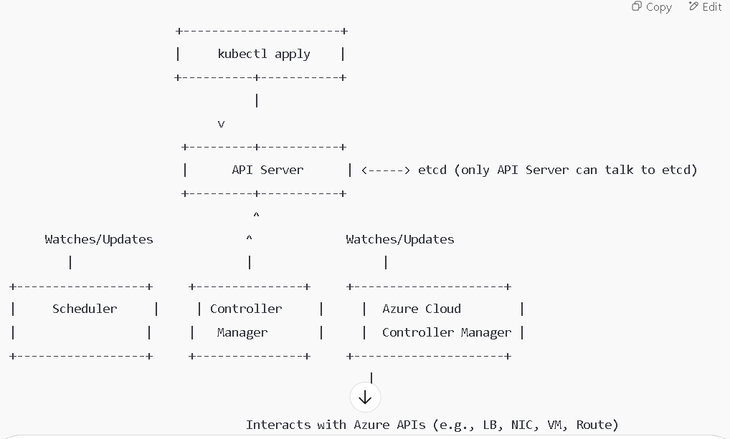



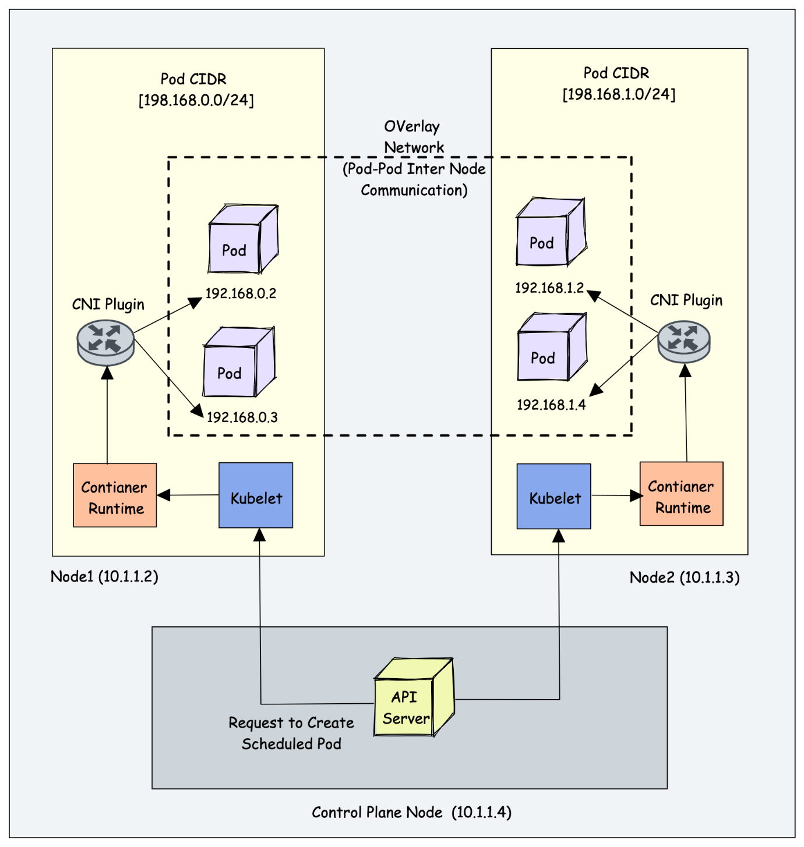

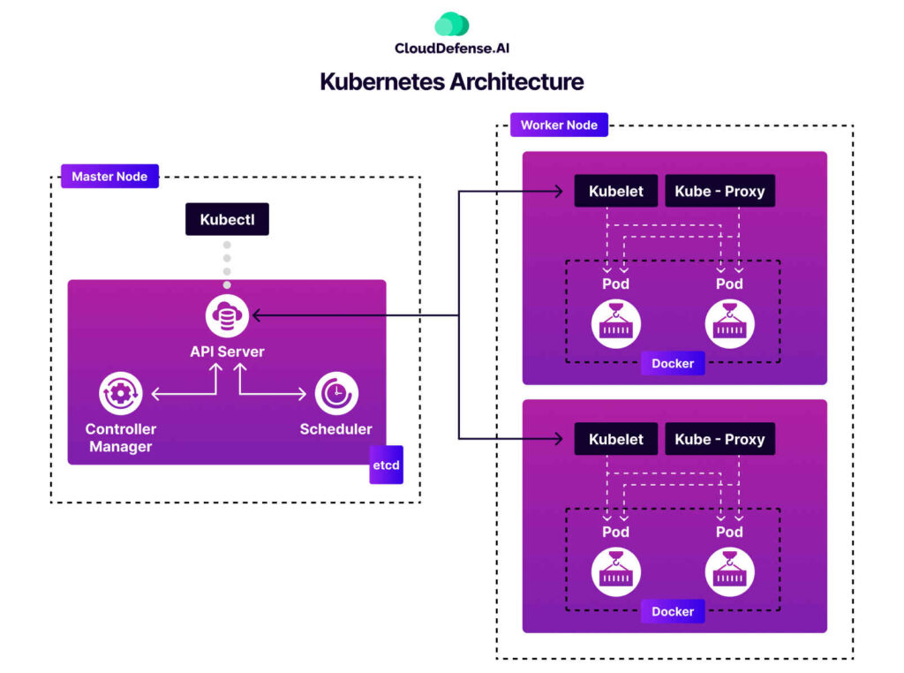



**Create Azure Kubernetes Cluster**

**What Is AKS Virtual Nodes?**

**Virtual Nodes** in AKS let your Kubernetes cluster **scale rapidly and elastically** — by using **Azure Container Instances (ACI)** as temporary "worker nodes" without actually managing VMs.

Think of them as:

⚡ "Just-in-time, serverless VMs" that run pods instantly when your cluster is full.

You run a shopping website hosted on AKS.

* On regular days, you run **3 nodes** in your node pool.
* On a big sale day, traffic **spikes massively**, and your 3 nodes can't handle it.

Normally, you’d Autoscale by adding VMs — but that takes 5–10 minutes per VM.

👉 Instead of waiting, **AKS Virtual Nodes** use **ACI** to instantly launch pods **outside your node pool**.

These are your "**on-demand burst pods**".

**🔧 How It Works (Technically)**

1. **You enable Virtual Nodes** in your AKS cluster (requires Azure CNI and a subnet)
2. AKS creates a special **“virtual-kubelet” node**
3. When your cluster is full (node autoscaler kicks in), extra pods are **scheduled onto the virtual node**
4. These pods are actually **running in Azure Container Instances (ACI)**
5. **✅ Benefits of Virtual Nodes**

| **Feature** | **Benefit** |
| --- | --- |
| ⚡ Fast | Pods start in **seconds**, not minutes |
| 💵 Cost-efficient | Pay only for the **seconds used** in ACI |
| 🧠 No VM management | No need to manage or patch extra nodes |
| 🔄 Auto-scaling | Integrates with HPA/KEDA easily |
| 💼 Great for burst workloads | Ideal for unpredictable traffic/jobs |
|  |  |

A payments company has batch jobs that run at 6 PM daily (100+ pods).  
Instead of scaling up 20 VMs (and paying for idle time), they:

* Keep just 5 base VMs
* Use Virtual Nodes to run the 100 pods on-demand
* Finish jobs in minutes and shut down automatically

**Virtual Kubelet + Azure Container Instances (ACI) = Azure Virtual Nodes in AKS**

**🔍 What Each Component Is**

**🔹 Virtual Kubelet**

* A **Kubernetes component** that **pretends to be a node**
* It **forwards pod scheduling requests** to an external container runtime (like ACI)
* Think of it as a **bridge between Kubernetes and ACI**

It's not a real VM — just an interface that makes ACI look like a node to Kubernetes

**Azure Container Instances (ACI)**

* A **serverless container runtime** in Azure
* Lets you run containers without managing VMs
* Charges **per second** for container execution time

When you **enable Virtual Nodes** in AKS:

1. Azure deploys a **Virtual Kubelet** into your AKS cluster
2. It registers as a special node in your cluster like:

